BODYMAP
(This must be completed at time of observation)

Name of Pupil: |  |  | Date of Birth:
Name of Staff: |  |  | Job title:
Date and time of observation:

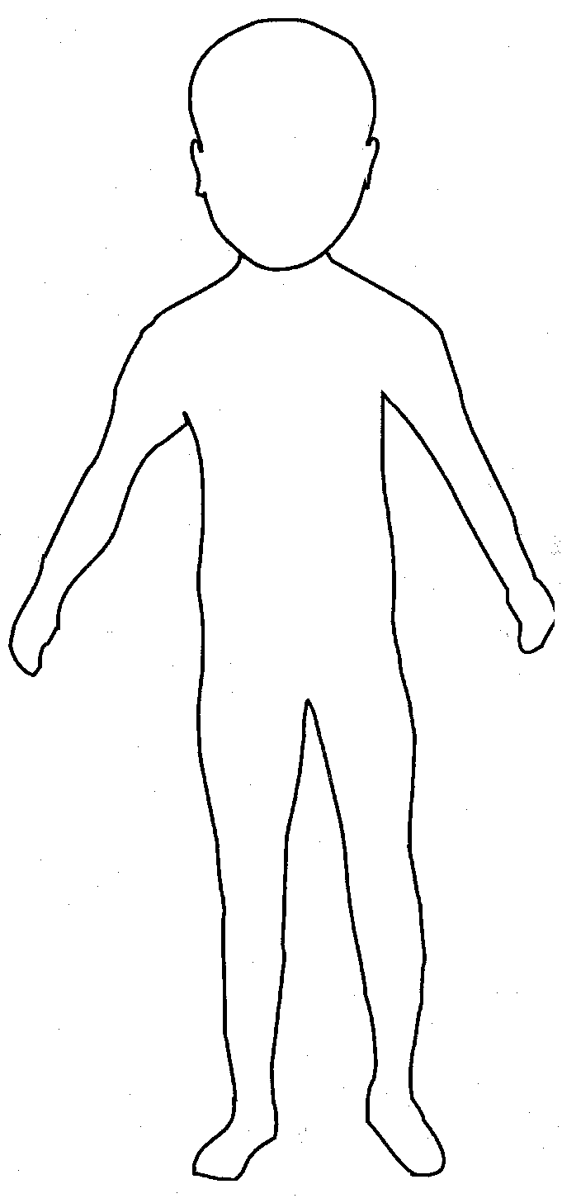 | 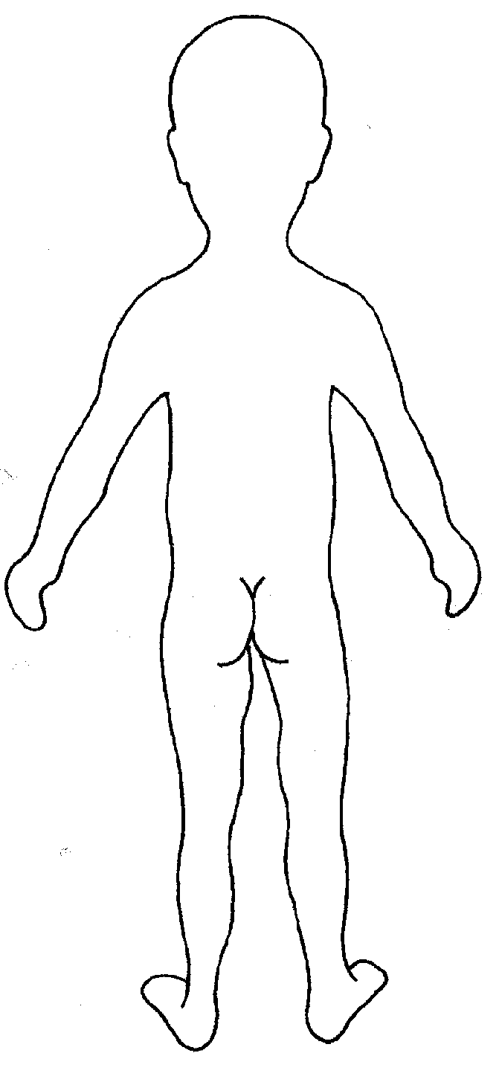

Name of pupil: |  |  | Date and time of observation:
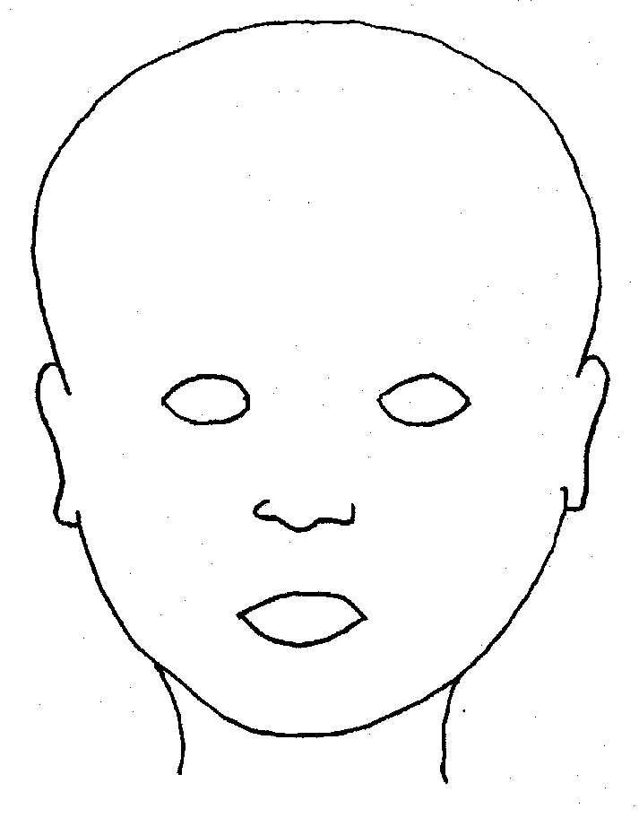 |  | 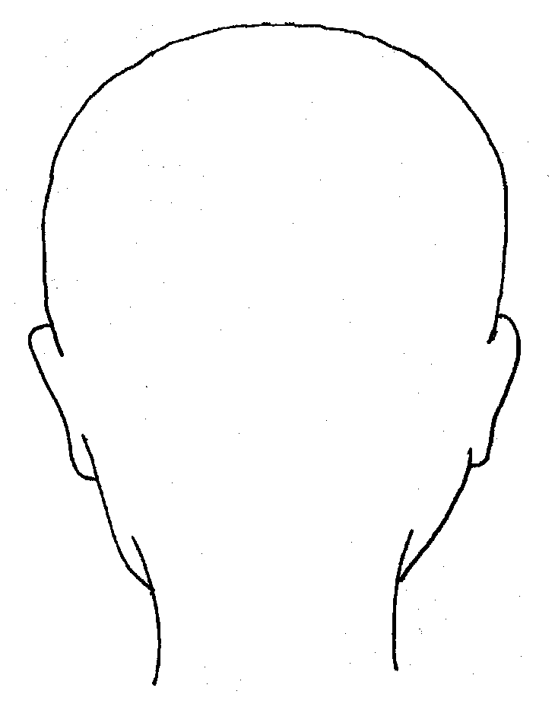
FRONT |  | BACK
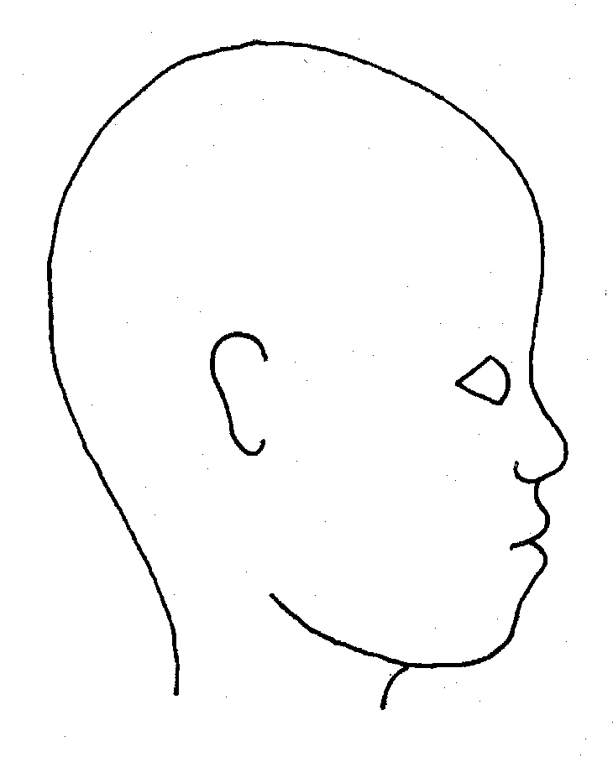 |  | 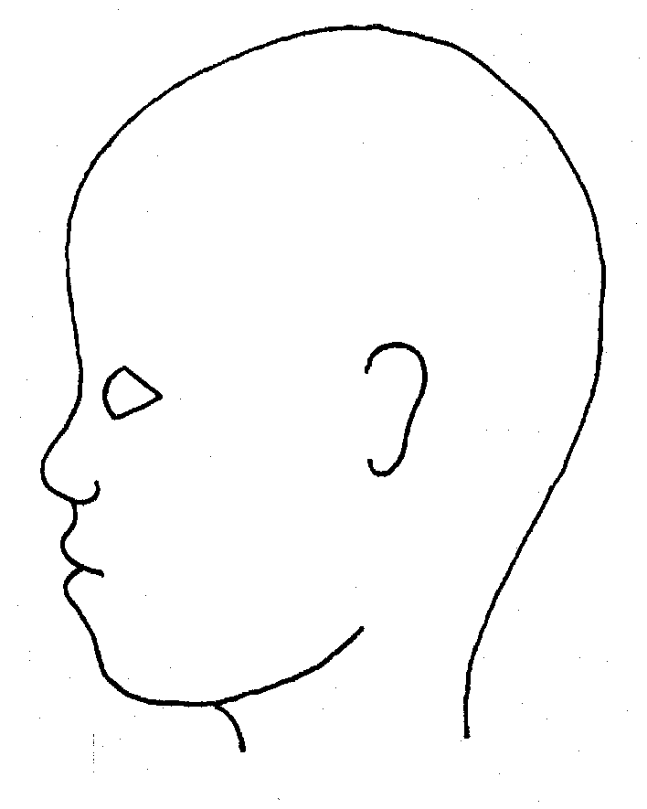
RIGHT |  | LEFT

Name of pupil: |  |  |  |  |  |  | Date and time of observation:
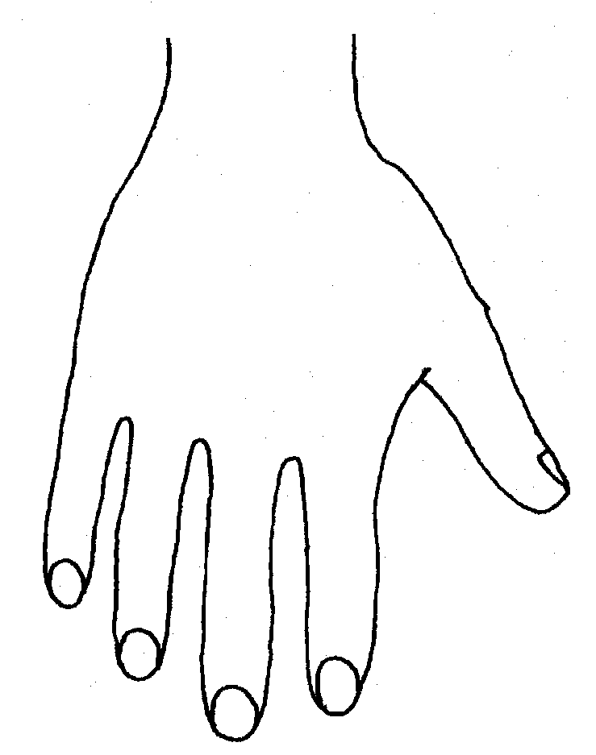 |  |  |  |  |  | 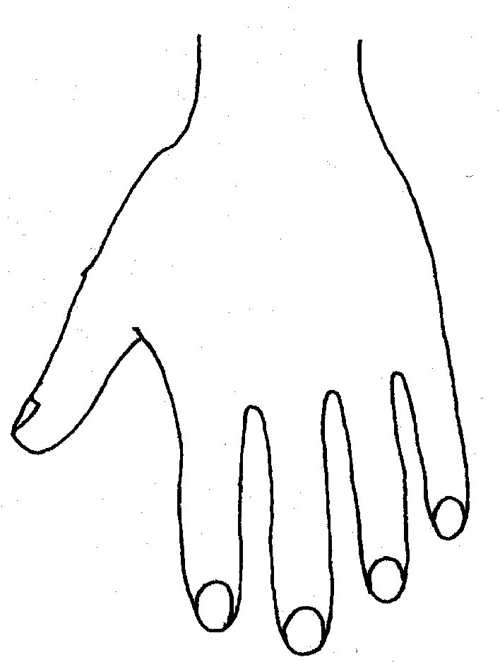
R |  |  |  |  |  | L
BACK
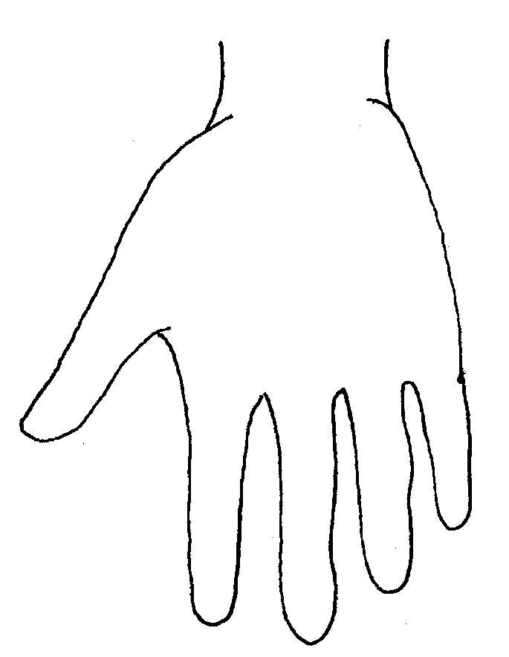 |  |  |  |  |  | 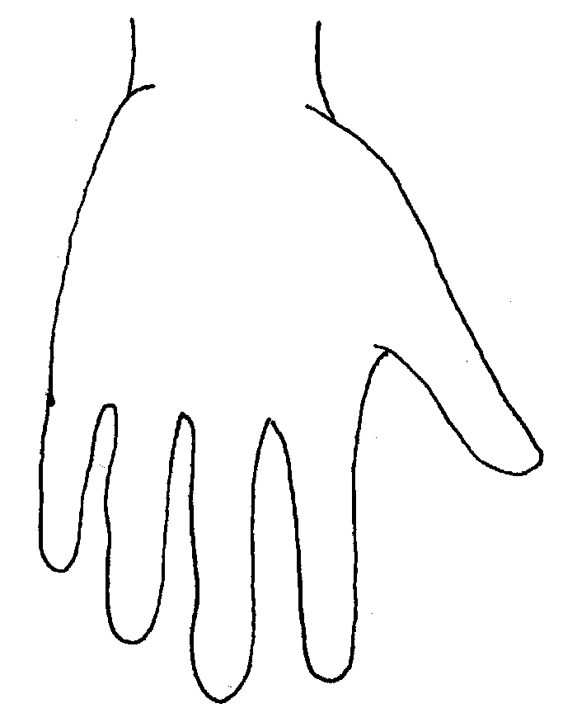
Name of Pupil: |  |  |  |  |  |  | Date and time of observation:
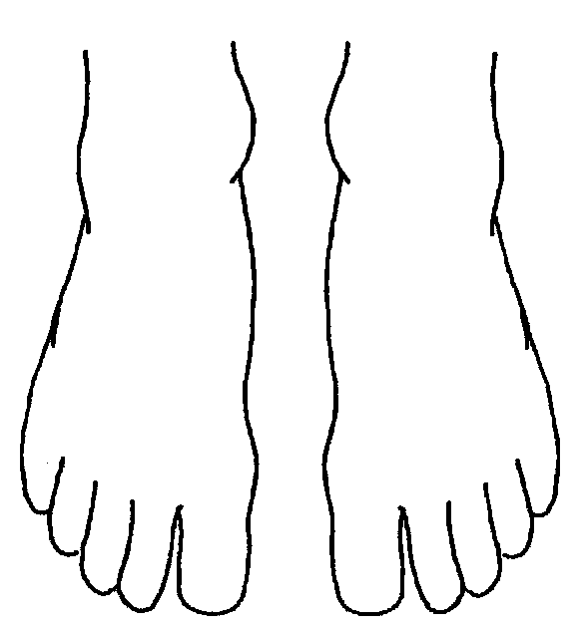 |  |  |  |  | 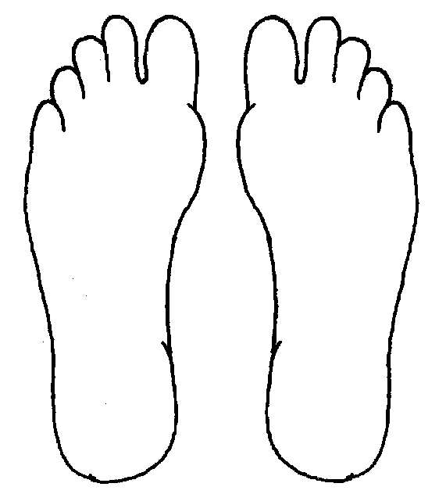
R | TOP |  |  | L | R |  |  | BOTTOM |  |  |  | L
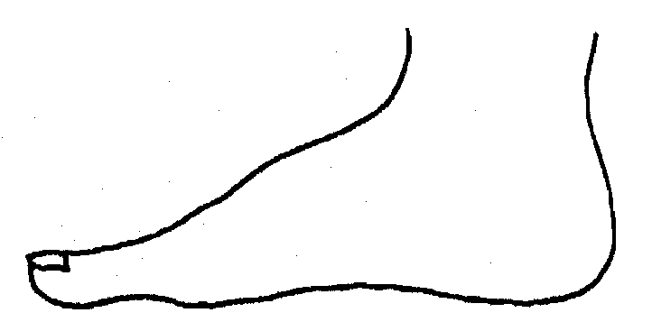 |  |  |  |  | 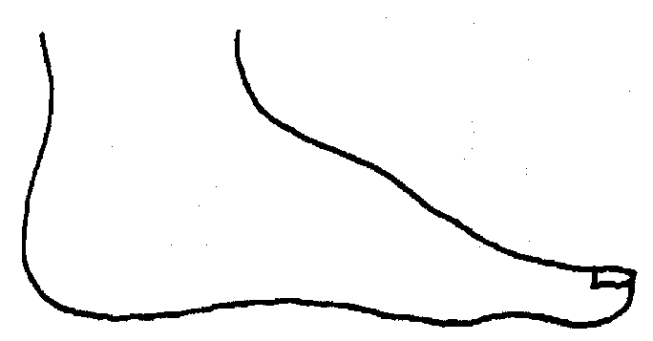
R |  |  |  |  | L
INNER
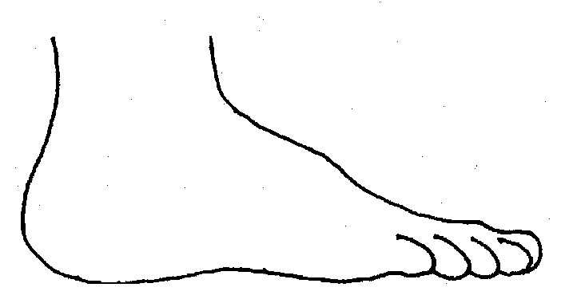 |  |  |  |  | 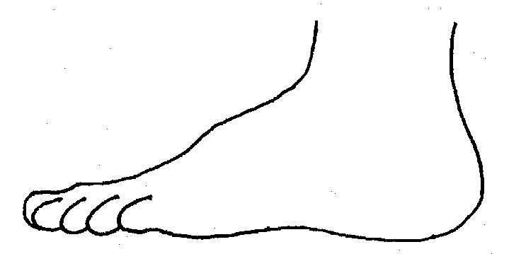
R |  |  |  |  | L
OUTER
Printed Name, Signature and Job title of staff:

